Output File

Step 1: Open command prompt using Admin, type ‘mongod’ command

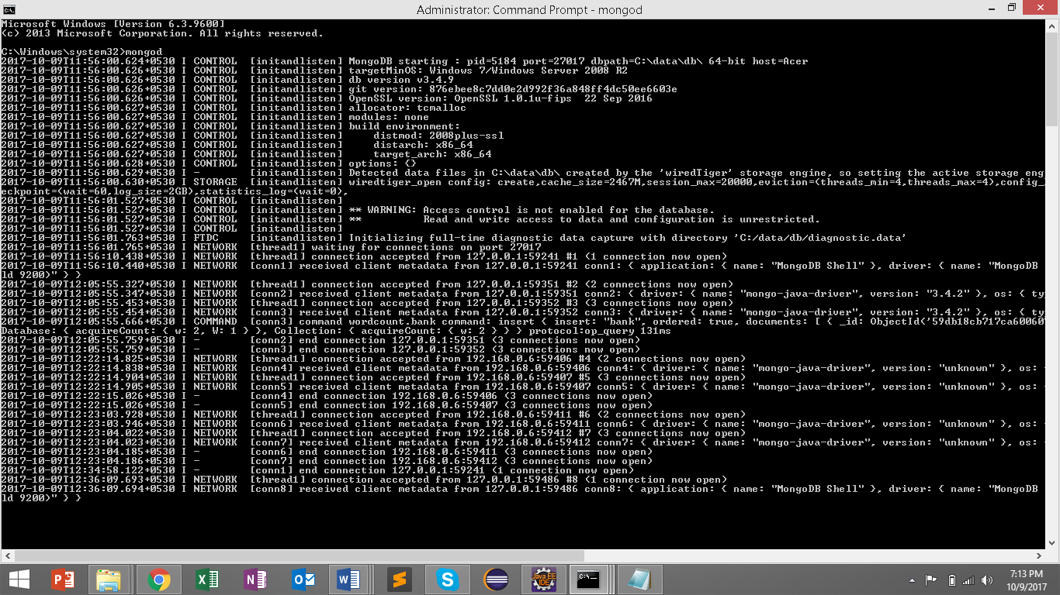

Step 2: Open command prompt using Admin, type ‘mongo’ command

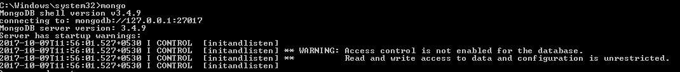

Step 3) Type ‘use wordcount’

C:\Users\User\AppData\Local\Microsoft\Windows\INetCache\Content.Word\cmd3.png

Step 4) Type ‘db.text.find().sort({word : -1}).limit(1)’

C:\Users\User\AppData\Local\Microsoft\Windows\INetCache\Content.Word\cmd4.png

Step 5) Type ‘db.bank.find({word : 6})

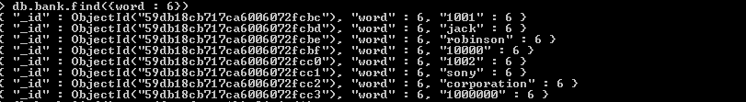

Step 6) Type ‘db.text.find().sort({word : +1}).limit(1)

C:\Users\User\AppData\Local\Microsoft\Windows\INetCache\Content.Word\cmd6.png

Step 7) Type ‘db.bank.find({word : 3})

C:\Users\User\AppData\Local\Microsoft\Windows\INetCache\Content.Word\cmd7.png

Command Prompt Output

java -jar d:\mongo\wordcount\WordCount-1-0.0.1-SNAPSHOT-jar-with-dependencies.jar d:\bank.xml 192.168.0.6:27017

Here, you can replace the input file (d:\bank.xml) with any of the xml file in which you want to find most and least frequency word count.

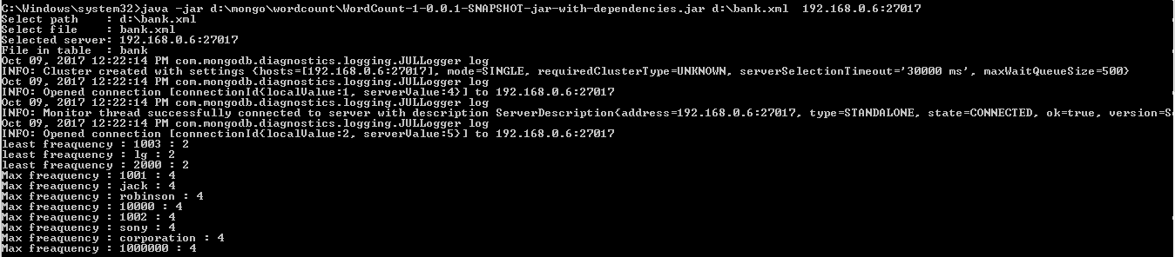

java -jar d:\mongo\wordcount\WordCount-1-0.0.1-SNAPSHOT-jar-with-dependencies.jar

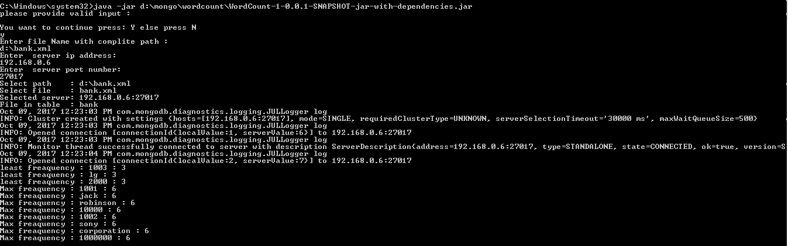

C:\Windows\system32>java -jar d:\mongo\wordcount\WordCount-1-0.0.1-SNAPSHOT-jar-with-dependencies.jar d:\ban.xml 192.168.0.6:27017

File does not exist :d:\ban.xml

C:\Windows\system32>java -jar d:\mongo\wordcount\WordCount-1-0.0.1-SNAPSHOT-jar-with-dependencies.jar

please provide valid input :

You want to continue press: Y else press N

n

C:\Windows\system32>java -jar d:\mongo\wordcount\WordCount-1-0.0.1-SNAPSHOT-jar-with-dependencies.jar

please provide valid input :

You want to continue press: Y else press N

y

Enter file Name with complite path :

d:\ban.xml

Enter server ip address:

192.168.0.6

Enter server port number:

27017

File does not exist :d:\ban.xml

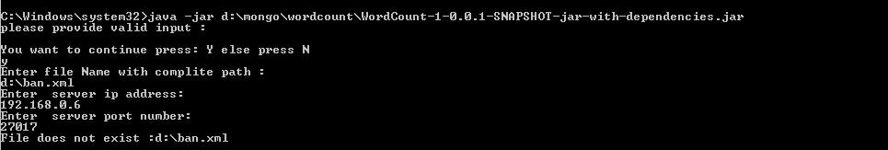

C:\Windows\system32>java -jar d:\mongo\wordcount\WordCount-1-0.0.1-SNAPSHOT-jar-with-dependencies.jar